***A brief description of the solution***:-

1. Extract product catalogue from ecommerce website
2. Convert the extracted product catalogue into target required format
3. Above steps needs to be repeated as and when change in catalogue on ecommerce website

***A high-level network and architecture diagram:-***

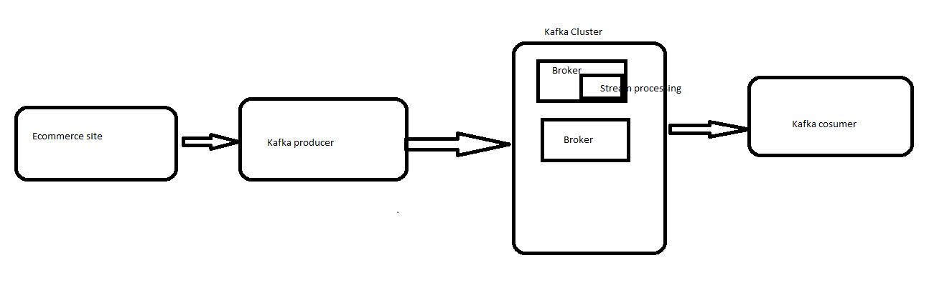

***A***[***logical breakdown***](https://softwaredominos.com/home/software-design-development-articles/from-abstract-concepts-to-tangible-value-solution-architecture-in-modern-it-systems/)***of the solution:-***

1. Ecommerce changes needs to tracked and extracted catalogue by using kafka producer.
2. Producer needs to public extracted catalogue details to kafka topic
3. Using kafka streaming processing convert the catalogue to required format.
4. Here google/Facebook web Api should act as consumer and subscribe the topic